Registration Now Open!
Space Limited
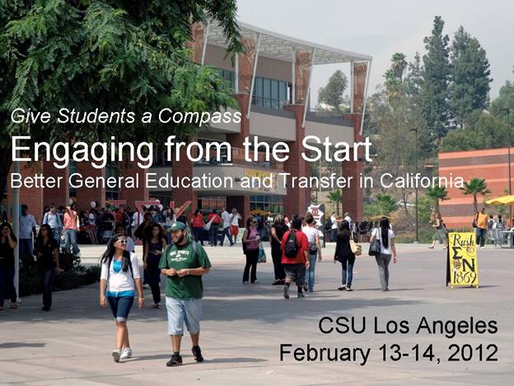

JOIN COLLEAGUES from the California Community Colleges and California State University to explore ways we can improve general education (GE) policy and practice to make it more engaging, relevant, and transformational. We seek guidance from faculty, administrators, staff, and students across both systems as we explore new approaches in the GE transfer curriculum.

WHO SHOULD ATTEND: Faculty (especially those involved with the GE transfer curriculum and campus and state senators), academic affairs administrators, articulation officers, institutional research directors, academic advisors, and students.

EMPLOYERS tell us that they want colleges to place more emphasis on written and oral communication, critical and creative thinking, problem-solving, teamwork in diverse groups, quantitative reasoning, and integrative and applied learning – content that is at the core of GE.
Yet students frequently wonder, “Why do I have to take these courses?” and many faculty members focus on students majoring in their own disciplines. Whether students begin at a 2-year or 4-year college, they are most likely to drop out in their first two years – when they are taking GE. Research shows that students who become actively engaged in learning through high-impact practices like learning communities, research with faculty, service-learning and/or first-year experiences learn better and are more likely to persist.

WHAT CAN WE LEARN from innovative practices already in place? How can GE curriculum help students achieve the LEAP “Essential Learning Outcomes” (see www.aacu.org/leap/vision)? Can we articulate transfer credit based on demonstrated learning rather than class time? Should we require all students to participate in high-impact practices like learning communities, service-learning, research, and/or first-year experiences? How would change affect faculty work? What evidence do we need to inform decisions? These are some of the questions that we will consider.

The conference will also highlight work underway through the “Give Students a Compass” Initiative (see www.calstate.edu/app/compass), the Association of American Colleges and Universities’ Quality Collaboratives projects (see www.aacu.org/qc), and the Western Interstate Commission on Higher Education’s Interstate Passport Initiative (see wiche.edu/news/release/15306).

FEATURED SPEAKERS:
Brian Murphy, President, DeAnza College
José Cruz, Vice President for Higher Education Policy and Practice, The Education Trust
Susan Albertine, Vice President for Engagement, Inclusion, and Success, Association of
American Colleges and Universities

DATE/TIME: The conference will begin at 10 a.m. on Monday, February 13, 2012 (registration at 9:30 a.m.) and end at 12:15 p.m. on Tuesday, February 14. There will be a meeting and lunch for grantees from pilot projects and networking partnerships supported by the Compass Initiative from 12:30 to 2:30 p.m. on February 14.

COST: Regular rate: $125
Discounted rate for networking partnership campuses: $95 (Contact CSU Chancellor’s Office at 562-951-4770 for code)
Pilot site representatives, students, and invited guests: (Contact CSU Chancellor’s Office at 562-951-4770 for code)

Registration fees include lunch and dinner on the first day, breakfast on the second day, and breaks on both days are included. (Lunch on the second day is included for grantees from pilot projects and networking partnerships.)

REGISTRATION SITE:
Register at: http://www.regonline.com/Register/Checkin.aspx?EventID=1044437
DEADLINE for conference registration: Friday, February 3, 2012.
Questions about registration? Call 562-951-4770.

MEETING LOCATION: The meeting will be held at the Conference Center, California State University, Los Angeles – 5151 State University Drive, Los Angeles, CA 90032.

HOTEL: A block of rooms has been reserved for the CSU Chancellor’s Office at a rate of $149 a night plus tax at:
Courtyard by Marriott, Old Pasadena
180 North Fair Oaks Avenue
Pasadena, CA 91103
Reservation deadline: Thursday, January 19, 2012

Shuttles from campus to the hotel will be available Monday evening and back to
Campus on Tuesday morning (limited capacity; please indicate on registration form
if you plan to use this service).

SCHEDULE AT A GLANCE:
Monday, February 13, 2012
9:30 to 10:00 a.m. Registration; coffee.
10:00 a.m. to 12 noon Opening plenary featuring José Cruz
12:00 noon to 2:00 p.m. Lunch and plenary featuring Susan Albertine
2:15 to 5:00 p.m. Working groups
5:00 to 6:00 p.m. Reception and poster session
6:00 to 8:00 p.m. Dinner and plenary featuring Brian Murphy
8:15 p.m. Shuttles from campus to hotel

Tuesday, February 14, 2012
8:00 a.m. Shuttles from hotel to campus
8:15 to 9:15 a.m. Breakfast
9:15 to 10:15 a.m. Plenary panel on articulation
10:30 to 11:30 a.m. Working groups
11:30 a.m. to 12:15 p.m. Next steps and closing
12:30 to 2:30 p.m. Grantee lunch and meeting

